# Node.js Express project tutorial:

# **Project 1:**

**Step 1.** Terminal >>>

npm install express

or

npm install -g express-generator

**Step 2.**

Terminal >>> npm install

**Step 3.** Make a app.js file with the following code:

app.js: Express.js Web Server

var express = require('express');

var app = express();

// define routes here..

var server = app.listen(5000, function () {

console.log('Node server is running..');

});

To run the code: in terminal type>>>> node app.js

Output: Node server is running..

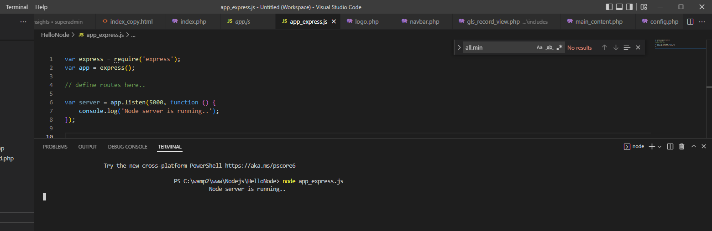

**Step 4.**

Configure Routes in Express.js

var express = require('express');

var app = express();

app.get('/', function (req, res) {

res.send('<html><body><h1>Hello World</h1></body></html>');

});

app.post('/submit-data', function (req, res) {

res.send('POST Request');

});

app.put('/update-data', function (req, res) {

res.send('PUT Request');

});

app.delete('/delete-data', function (req, res) {

res.send('DELETE Request');

});

var server = app.listen(5000, function () {

console.log('Node server is running..');

});

Output in the browser: <http://localhost:5000/> >>>>> Hello World

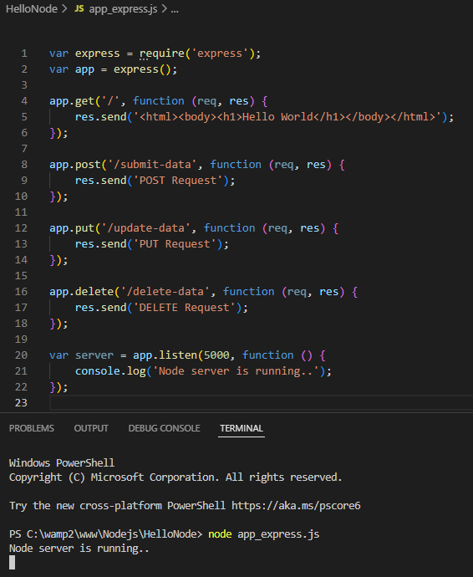 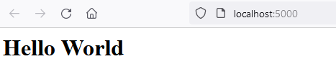

# **Project 2: (**Handle POST Route in Express.js**)**

Body Parser for middle ware:

To handle HTTP POST request in Express.js version 4 and above, you need to install middleware module called [body-parser](https://github.com/expressjs/body-parser). The middleware was a part of Express.js earlier but now you have to install it separately.

This body-parser module parses the JSON, buffer, string and url encoded data submitted using HTTP POST request. Install body-parser using NPM as shown below.

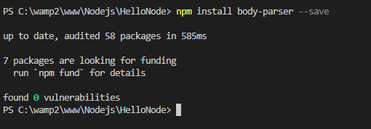

Step 1: Create .html file

<!DOCTYPE html>

<html xmlns="http://www.w3.org/1999/xhtml">

<head>

<meta charset="utf-8" />

<title></title>

</head>

<body>

<form action="/submit-student-data" method="post">

First Name: <input name="firstName" type="text" /> <br />

Last Name: <input name="lastName" type="text" /> <br />

<input type="submit" />

</form>

</body>

</html>

Step 2: Install Body Parser:

npm install body-parser --save

Step 3: create a app.js

var express = require('express');

var app = express();

var bodyParser = require("body-parser");

app.use(bodyParser.urlencoded({ extended: false }));

app.get('/', function (req, res) {

//res.sendFile('index.html');

res.sendFile(__dirname + '/index.html');

});

app.post('/submit-student-data', function (req, res) {

var name = req.body.firstName + ' ' + req.body.lastName;

res.send(name + ' Submitted Successfully!');

});

var server = app.listen(5000, function () {

console.log('Node server is running..');

});

Step 4: Run app.js on terminal

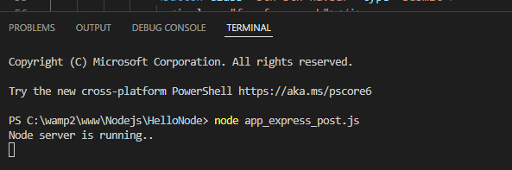

Step 5: Run > Browser > <http://localhost:5000>

Output

